%matplotlib inline

import matplotlib.pyplot as plt

import numpy as np

X = np.array(

[[7,8],[12,20],[17,19],[26,15],[32,37],[87,75],[73,85], [62,80],[73,60],[87,96],])

labels = range(1, 11)

plt.figure(figsize = (10, 7))

plt.subplots_adjust(bottom = 0.1)

plt.scatter(X[:,0],X[:,1], label = 'True Position')

for label, x, y in zip(labels, X[:, 0], X[:, 1]):

plt.annotate(

label,xy = (x, y), xytext = (-3, 3),textcoords = 'offset points', ha = 'right', va = 'bottom')

plt.show()

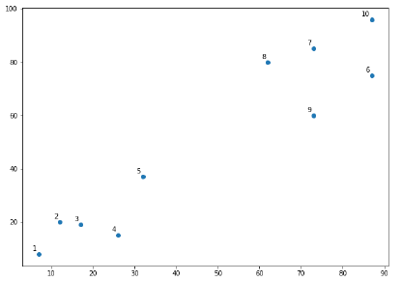

From the above diagram, it is very easy to see that we have two clusters in out datapoints but in the real world data, there can be thousands of clusters.

Next, we will be plotting the dendrograms of our datapoints by using Scipy library −

from scipy.cluster.hierarchy import dendrogram, linkage

from matplotlib import pyplot as plt

linked = linkage(X, 'single')

labelList = range(1, 11)

plt.figure(figsize = (10, 7))

dendrogram(linked, orientation = 'top',labels = labelList,

distance_sort ='descending',show_leaf_counts = True)

plt.show()

|  |  |
| --- | --- |
| Now, once the big cluster is formed, the longest vertical distance is selected. | Plotting the Dendrograms |
| A vertical line is then drawn through it as shown in the following diagram. As the horizontal line crosses the blue line at two points, the number of clusters would be two. | Blue Line |

El dendrograma nos dice

* Azul- abarca todo los puntos
* Verde – un cluster
* Rojo – otro cluster

Next, we need to import the class for clustering and call its fit_predict method to predict the cluster.

We are importing *AgglomerativeClustering* class of *sklearn.cluster* library

from sklearn.cluster import AgglomerativeClustering

cluster = AgglomerativeClustering(n_clusters = 2, affinity = 'euclidean', linkage = 'ward')

cluster.fit_predict(X)

Next, plot the cluster with the help of following code –

plt.scatter(X[:,0],X[:,1], c = cluster.labels_, cmap = ‘rainbow’)

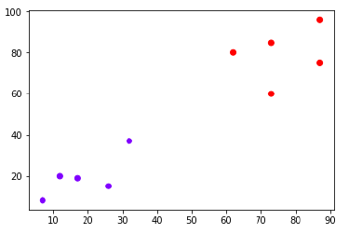

The above diagram shows the two clusters from our datapoints.